# Tugas Pemrograman Berorientasi Objek



**Muhamad Salman Adhim Baqy**

**A11.2020.12641**

**Fakultas Ilmu Komputer**

**Program Studi Teknik Informatika**

**Universitas Dian Nuswantoro**

**2022**

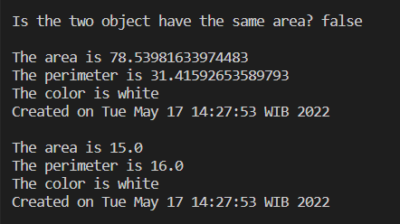Abstract

GeometriObject.java

|  |
| --- |
| package Abstract;  public abstract class GeometriObject {      private String color = "white";      private boolean filled;      private java.util.Date dateCreated;      protected GeometriObject() {          dateCreated = new java.util.Date();      }      protected GeometriObject(String color, boolean filled) {          dateCreated = new java.util.Date();          setColor(color);          setFilled(filled);      }      public String getColor() {          return this.color;      }      public void setColor(String color) {          this.color = color;      }      public boolean isFilled() {          return this.filled;      }      public void setFilled(boolean filled) {          this.filled = filled;      }      public java.util.Date getDateCreated() {          return this.dateCreated;      }      @Override      public String toString() {          return "Created on " + dateCreated + "\nColor : " + color + " and filled : " + filled;      }      public abstract double getArea();      public abstract double getPerimeter();  } |

Circle.java

|  |
| --- |
| package Abstract;  public class Circle extends GeometriObject {      private double radius;      public Circle() {      }      public Circle(double radius) {          setRadius(radius);      }      public Circle(double radius, String color, boolean filled) {          setRadius(radius);          setColor(color);          setFilled(filled);      }      public double getRadius() {          return this.radius;      }      public void setRadius(double radius) {          this.radius = radius;      }      public double getDiameter() {          return radius + radius;      }      @Override      public double getArea() {          // TODO Auto-generated method stub          return radius * radius * Math.PI;      }      @Override      public double getPerimeter() {          // TODO Auto-generated method stub          return 2 * radius * Math.PI;      }  } |

Rectangle.java

|  |
| --- |
| package Abstract;  public class Rectangle extends GeometriObject {      private double width;      private double height;      public Rectangle() {      }      public Rectangle(double width, double height) {          setWidth(width);          setHeight(height);      }      public Rectangle(double width, double height, String color, boolean filled) {          setWidth(width);          setHeight(height);          setColor(color);          setFilled(filled);      }      public double getWidth() {          return this.width;      }      public void setWidth(double width) {          this.width = width;      }      public double getHeight() {          return this.height;      }      public void setHeight(double height) {          this.height = height;      }      @Override      public double getArea() {          // TODO Auto-generated method stub          return width * height;      }      @Override      public double getPerimeter() {          // TODO Auto-generated method stub          return 2 * (width + height);      }  } |

Demo.java

|  |
| --- |
| package Abstract;  public class Demo {      private static boolean equalArea(GeometriObject geoObj1, GeometriObject geoObj2) {          return geoObj1.getArea() == geoObj2.getArea();      }      private static void displayGeometriObject(GeometriObject geoObj) {          System.out.println("\nThe area is " + geoObj.getArea());          System.out.println("The perimeter is " + geoObj.getPerimeter());          System.out.println("The color is " + geoObj.getColor());          System.out.println("Created on " + geoObj.getDateCreated());      }      public static void main(String[] args) {          GeometriObject geoObj1 = new Circle(5);          GeometriObject geoObj2 = new Rectangle(5, 3);          System.out.println("\nIs the two object have the same area? " + equalArea(geoObj1, geoObj2));          // Display circle          displayGeometriObject(geoObj1);          // Display rectangle          displayGeometriObject(geoObj2);          System.out.println("");      }  } |

Interface

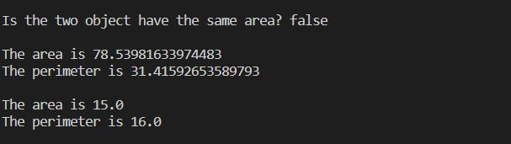

GeometriObject.java

|  |
| --- |
| package Interface;  public abstract class GeometriObject {      private String color = "white";      private boolean filled;      private java.util.Date dateCreated;      protected GeometriObject() {          dateCreated = new java.util.Date();      }      protected GeometriObject(String color, boolean filled) {          dateCreated = new java.util.Date();          setColor(color);          setFilled(filled);      }      public String getColor() {          return this.color;      }      public void setColor(String color) {          this.color = color;      }      public boolean isFilled() {          return this.filled;      }      public void setFilled(boolean filled) {          this.filled = filled;      }      public java.util.Date getDateCreated() {          return this.dateCreated;      }      @Override      public String toString() {          return "Created on " + dateCreated + "\nColor : " + color + " and filled : " + filled;      }      public abstract double getArea();      public abstract double getPerimeter();  } |

Benefit.java

|  |
| --- |
| package Interface;  public interface Benefit {      public abstract void application();  } |

Circle.java

|  |
| --- |
| package Interface;  public class Circle extends GeometriObject implements Benefit {      private double radius;      public Circle() {      }      public Circle(double radius) {          setRadius(radius);      }      public Circle(double radius, String color, boolean filled) {          setRadius(radius);          setColor(color);          setFilled(filled);      }      public double getRadius() {          return this.radius;      }      public void setRadius(double radius) {          this.radius = radius;      }      public double getDiameter() {          return radius + radius;      }      @Override      public double getArea() {          // TODO Auto-generated method stub          return radius * radius * Math.PI;      }      @Override      public double getPerimeter() {          // TODO Auto-generated method stub          return 2 * radius * Math.PI;      }      @Override      public void application() {          // TODO Auto-generated method stub          System.out.println("Circle are on wheels, rings, clocks, etc");      }  } |

Square.java

|  |
| --- |
| package Interface;  public class Square implements Benefit {      @Override      public void application() {          // TODO Auto-generated method stub          System.out.println("Square are on dice, cube, aquarium, etc");      }  } |

Demo.java

|  |
| --- |
| package Interface;  public class Demo {      public static void main(String[] args) {          Circle c = new Circle();          c.setRadius(5);          System.out.println("\nThe circle's area is " + c.getArea());          System.out.println("The circle's permieter is " + c.getPerimeter());          c.application();          System.out.println("");          Square s = new Square();          s.application();          System.out.println("");      }  } |